Using the ChemE Visit Weekend Scheduling Code

By Garrett Dowdy ([gdowdy3@gmail.com](mailto:gdowdy3@gmail.com))

# Introduction

This document describes how to use a code to schedule ChemE visit weekend meetings between visitors and faculty. While conceptually simple, creating a schedule for these interviews can be a very tedious task. The code described herein eliminates this tedium.

The code takes in the availability data of the visitors and faculty and constructs a meeting schedule in which:

* Each visitor is assigned to either a meeting with a faculty member or free time for each time period.
* Each faculty meets with at most one student during any given period.
* Visitors are only assigned to meet with faculty when the faculty are available.
* Each visitor-faculty pair meets at most once.
* Each visitor has a minimum amount of free time, which you as the user can specify.
* Each visitor has a minimum number of faculty meetings, which you as the user can specify.
* Each visitor has at most one meeting during the TG.

The code takes about seconds to minutes to run, which is much less time than would be required to construct the schedule manually.

The following pages explain what is required to run the code and view its output.

# Using JuliaBox for the First Time

You don’t have to install anything to run the code. Instead, you will run it in your browser via a website called [www.juliabox.org](http://www.juliabox.org).

1. Go to [www.juliabox.org](http://www.juliabox.org).
2. Sign in via LinkedIn, GitHub, or Google.
3. Create a new folder to hold the code and the associated files.
   1. Click on the **New** dropdown menu in the top right corner of your screen.
   2. Select **Folder** from the dropdown menu.
   3. Rename the newly created **Untitled Folder** by clicking the checkbox to its left and then clicking the **Rename** button that appears above.
   4. You can name it whatever you like, but I recommend “ChemE Visit Weekend Scheduling”
4. Enter the folder by clicking on its new name.
5. Upload the “ChemE Visit Weekend Scheduling.ipynb” file.
   1. Save the “ChemE Visit Weekend.ipynb” attachment to your computer. It doesn’t matter where you save it, so long as you know where it is.
   2. Click on the **Upload** button in the top right corner of the JuliaBox screen.
   3. Navigate to the location of the “ChemE Visit Weekend Scheduling.ipynb” file, select it, and click **Open**.
   4. Click the blue **Upload** button.
6. Upload the necessary input files.
   1. The two input files are called “Visitor Preferences.csv” and “Faculty Availability.csv”.
   2. You may be using files sent to you by Garrett, or you may be using files that you created yourself.
   3. Either way, the upload procedure is the same as in the previous step.
   4. *DO NOT* rename the files. The code expects them to be named *exactly* as described above, and will throw an error if they are not.
   5. The code also expects that these input files have a specific format. For details, see the “Format of the Input Files” section below.
7. Open the “ChemE Visit Weekend Scheduling.ipynb” file by clicking on its name.
8. Read the introduction and follow the instructions contained therein.

# Format of the Input Files

As stated above, there are two input files:

* Visitor Preferences.csv
* Faculty Availability.csv

The code expects these two input files to have a specific format. In this section, the required format is explained.

## Visitor Preferences

The visitor preferences input is very simple.

* The first column contains the names of the visitors. The exact formatting of the name is unimportant. Just know that whatever names you enter here will show up on the output files.

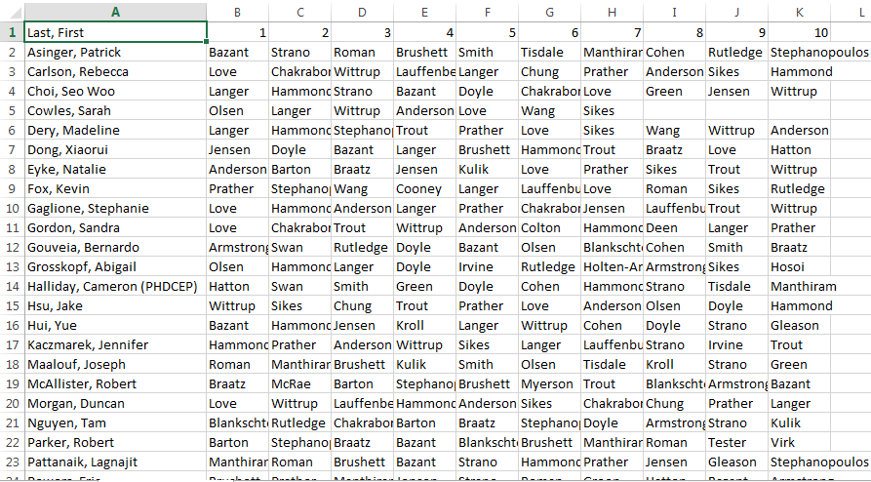

* Columns B through K contain the visitors’ preferences for faculty meetings. The column labeled with a “1” should contain each visitor’s top choice – the faculty member they are most eager to meet. The column labeled with “2” should contain the name of the faculty member they are second most eager to meet, and so on, down to the column labeled with a “10”.

If you have incomplete preference data for a visitor, that’s OK. You can leave any of the cells blank, as in the case of “Cowles, Sarah” in the example below.



## Faculty Availability

The faculty availability input is also simple.

* The first column contains the name of each faculty member. Make sure the formatting of these names is the same as the formatting of the faculty names appearing in the “Visitor Preferences.csv” input.

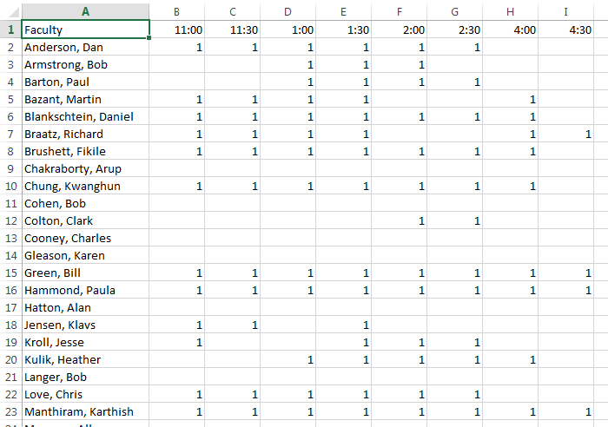

* The remaining columns indicate the faculty members’ availability during each time period. A value of “1” indicates that the faculty member is available during the time indicated at the top of the column. A blank cell indicates that a faculty member is not available.

Notice that there are 8 periods. If you want to change this, you will need Garrett’s help.



# Inspecting the Output

1. The “ChemE Visit Weekend Scheduling.ipynb” code will produce two files in your JuliaBox folder:
   1. “Visitor-Focused Output.csv”
   2. “Faculty-Focused Output.csv”
2. Save these files to your computer.
   1. On the screen where you are looking at the contents of the JuliaBox folder, the word “Files” appears twice:
      1. Once in the top left corner of your screen, right underneath the fun, colorful JuliaBox logo,
      2. Once to the right of this logo, closer to the center of your screen. This second instance of the word has a little gray symbol next to it, suggestive of “upload”.
   2. Click on the *second* instance of the word “Files”, the one in gray, with the “upload” symbol.
   3. Click on the text “Visitor-Focused Output.csv”.
   4. Save it to any old place you’d like on your computer.
   5. Do the same for the “Faculty-Focused Output.csv”.
3. Open the file using Excel and manipulate it as you see fit.

You should expect to see something like this for the visitor-focused output:

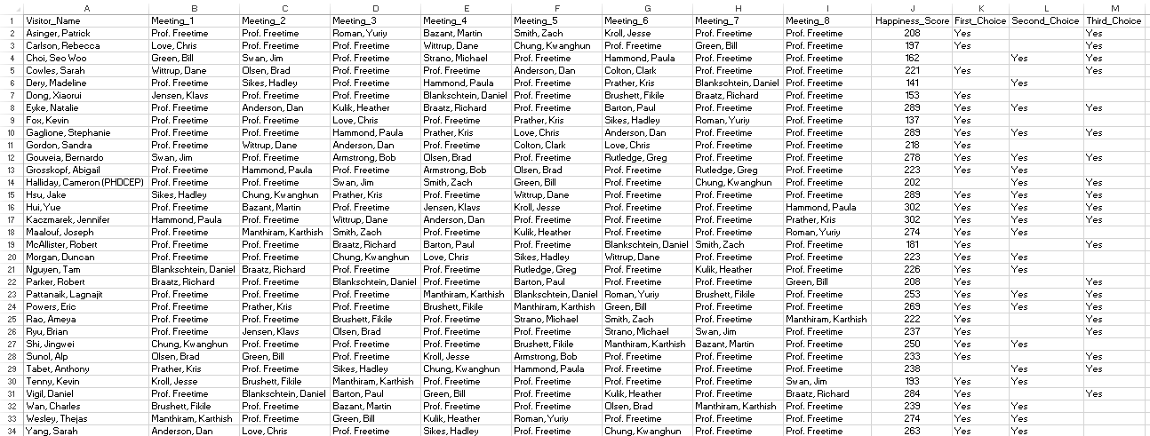

The “Happiness_Score” column on the right gives you a sense of each visitor’s expected happiness with their schedule. If a visitor is assigned to meetings with a lot of their top choice faculty, they will have a high happiness score. On the other hand, if they didn’t get meetings with many of their top choice faculty, they will have a relatively low score.

The “First_Choice”, “Second_Choice”, and “Third_Choice” columns on the far right tell you explicitly whether or not the visitor was assigned to meetings with their first, second, and third choice faculty, respectively.

If a student is assigned a meeting with “Prof. Freetime”, this means (as you might guess) that they have a free period. “Prof. Freetime” is a relic of the days when Suzanne McGuire would produce these schedules. She thought it was funny, and so did I.

The faculty-focused output will look something like this:

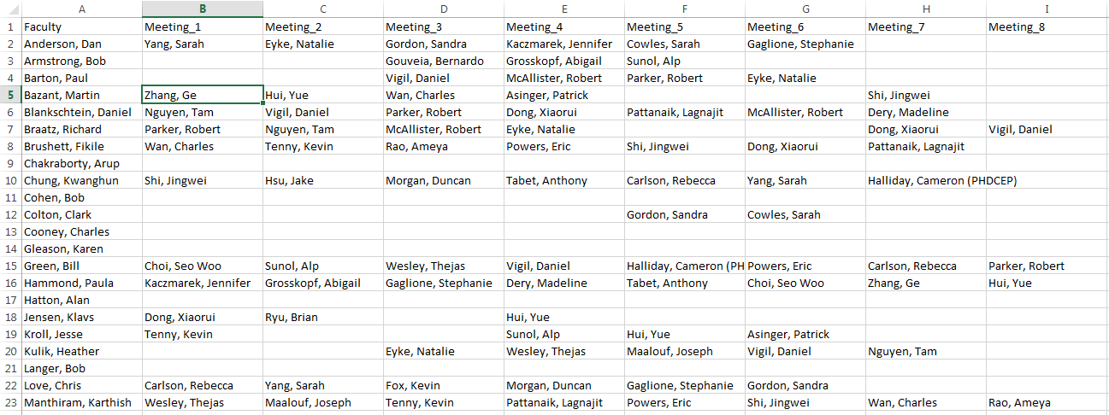

If a faculty member is available during a particular time period but was not assigned a meeting, the corresponding cell will be labeled “FREE”. On the other hand, if the cell is blank, that means the faculty member is not available during this time. In the example above, every period in which a faculty member was available for a meeting was used, so there are no “FREE”s visible.

You can apply whatever formatting you’d like to these two files to make them easier to read.

# Using JuliaBox on Subsequent Occasions

1. Go to [www.juliabox.org](http://www.juliabox.org).
2. Sign in via LinkedIn, GitHub, or Google.
3. Enter the folder you created previously for the ChemE Visit Weekend Scheduling code and associated files.
4. Upload any updated “Visitor Preferences.csv” or “Faculty Availability.csv” files.
5. Open the “ChemE Visit Weekend Scheduling.ipynb” file by clicking on its name.
6. Read the introduction and follow the instructions contained therein.